**React 01**

**Aim:** Create a new React Application with the name “myfirstreact”, Run the application to print “welcome to the first session of React” as heading of that page.

**PROGRAM:**

**App.css:**

.container {

text-align: center;

margin-top: 50px;

font-family: 'Segoe UI', Tahoma, Geneva, Verdana, sans-serif;

}

.header {

color: #2c3e50;

font-size: 2rem;

}

.btn {

padding: 10px 20px;

font-size: 1rem;

background-color: #3498db;

color: white;

border: none;

border-radius: 6px;

cursor: pointer;

margin-top: 20px;

}

.btn:hover {

background-color: #2980b9;

}

.message {

color: green;

font-weight: bold;

margin-top: 20px;

font-size: 1.2rem;

}

**APP.js:**

import React, { useState } from 'react';

import './App.css'; // Import external CSS

function App() {

const [message, setMessage] = useState('');

const handleClick = () => {

setMessage('You just clicked the button! 🎉');

};

return (

<div className="container">

<h1 className="header">Welcome to the first session of React</h1>

<button className="btn" onClick={handleClick}>Click Me</button>

{message && <p className="message">{message}</p>}

</div>

);

}

export default App;

**Output 1:**

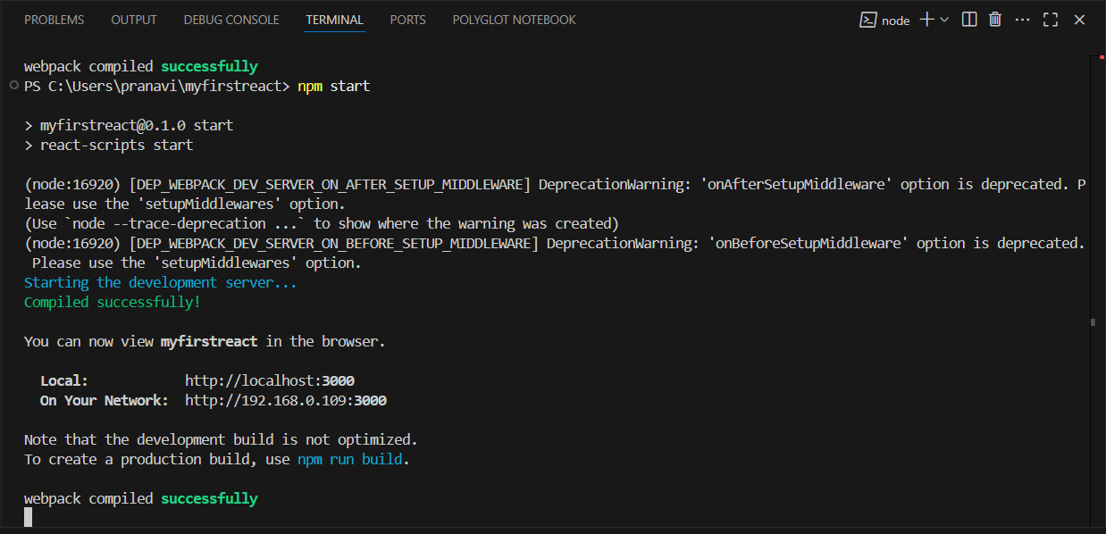

**Output 2:**

